Evergreen Park Schools Federal Credit Union

ONLINE BRANCH INSTRUCTIONS and E-STATEMENTS
To sign up for the Credit Union Online Branch, go to our website: www.epsfcu.org

- Click on the “SIGN IN” button along the top of the screen on the Home Page.
- User ID Enter your Member Account Number
- Password Enter the Last 4 Digits of your Social Security Number
- Now you will be prompted to change BOTH:
- Change your PASSWORD First and keep it in a safe place.
- Now Change your USER ID to something unique to you.
- A screen will appear showing your “Account Summary”
NOW YOU MAY SIGN UP FOR E-STATEMENTS
- Sign up for E-Statements
- Click on E-Statements along the green toolbar at the top of this screen
- Click “YES” to sign up for E-Statements
- You’re Done! Thank you!

PLEASE NOTE: The Credit Union needs to have your CURRENT EMAIL ADDRESS in our records in order for the system to reset a forgotten User ID or Password by sending you an email. Call us today to be sure your email is up to date.
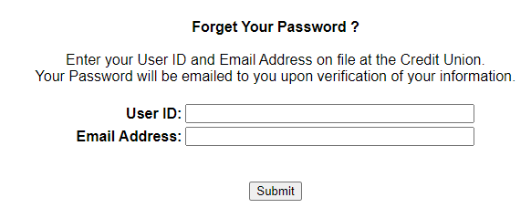

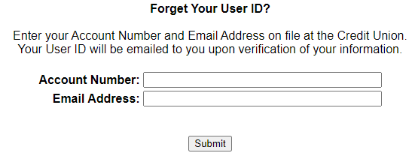
Contact the Credit Union with questions or to update your email address.

Your forgotten information may go to your Spam/Junk Mail.

